Drawing and Measuring Angles

Measure all the angles on the stick man.
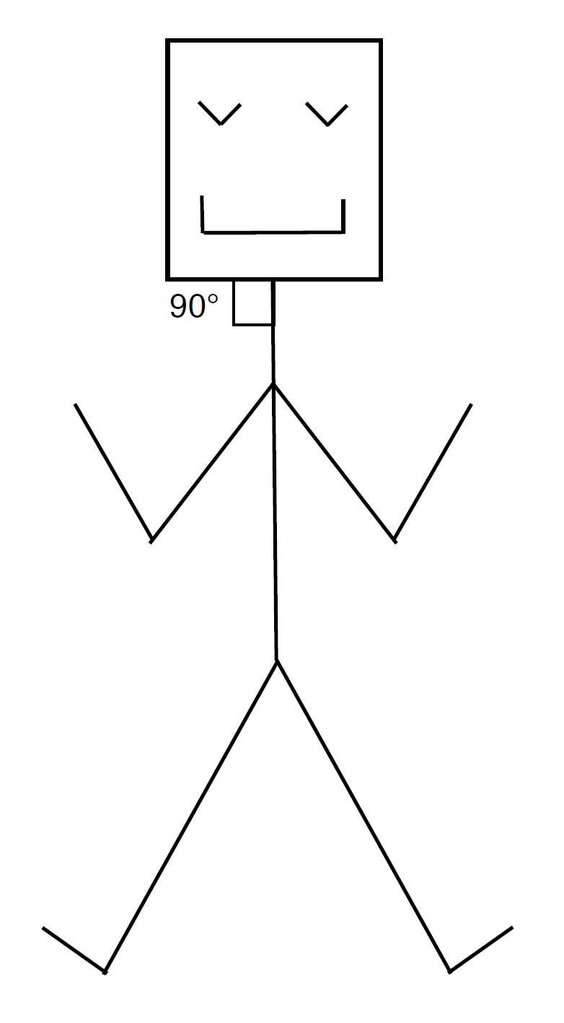

Draw the following angles.
